**Final Paper**

**Face Lock**

*By: Tamia Prince and Khaled Asad*

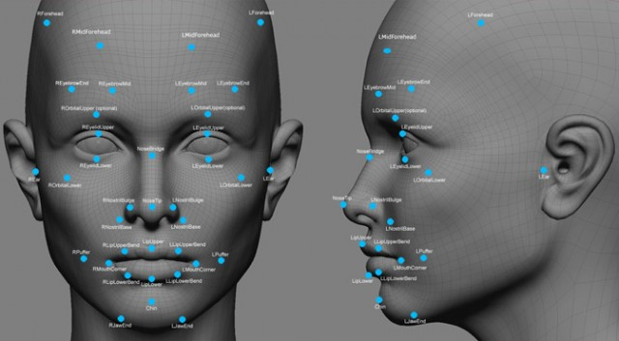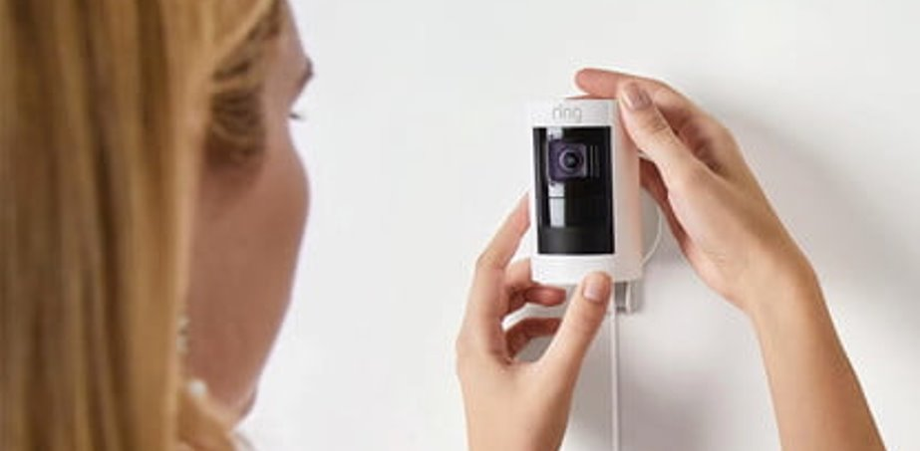

1. Introduction………………………………………………………………………….pg. 1
2. Architecture………………………………………………………………………….pg. 2
3. ETL…………………………………………………………………….…….…........pg. 3
4. Conclusion………………………..…………………………………………..……...pg. 12
5. References ………………………………………………………………………..….pg. 14

Introduction

The two sectors of security and image recognition have come together to manifest the success of the company we know as the *Ring*. My team, The Goats, brainstormed to take this idea even further to improve upon the security reaction capabilities that go along with their mission to help keep neighborhoods safe. My team approaches the ring security with a solution of personal image recognition that will recognize individuals and respond accordingly. Our ideas sparked from the fact that customers of can see a burglar braking into their home as they play it back from their ring footage but cannot prevent that intruder from gaining access. They also cannot allow access to guest they do recognize when they are not home. The way we would change this is by enabling specific faces that are familiar to the owner to be recognized by the system and granted access into the home. The problem of forgetting keys or having them stolen and having to change locks would be no more. When the system comes across an unrecognizable face it would prompt the user to decide whether they would like to let that person in. This would revolutionize security and lock systems and a great innovative initiative for Ring.

 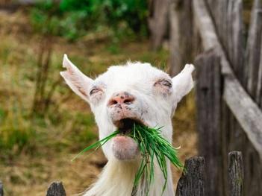[6]

Architecture

Our architecture plan starts with the data source. We will have two data sources one from the Yale University [1] and the other from our local machine’s cameras. The files themselves will be grayscale images. The images will be uploaded to the Google Cloud Platform (GCP). We will utilize the GCP service named Google Cloud Storage (GCS). As its name suggests it will be utilized to store our data sets. The reason for the choosing of Google Cloud Storage derived from our initial choice to work with another GCP service. The service will allow us to compute and work with grater computing power on demand then our local machines. The reason for this is, that our local machines do not have the sufficient and efficient power to compute the algorithms. As well this would be a safe and more effective way for our overall project automated independence. Meaning, if we were to implement this on larger scale we can easily do so. Whereas if we maintained and developed the “ipynb” files locally we could not share the product to its fullest. For example, if we had a customer in San Francisco, CA we wouldn’t have to ask the customer for their facial pictures. Instead, they would take the photos themselves and upload it via their phone or any computer. From there the GCP would automate the process for them and generate “YML” that would be then used on any facial recognition device that has a camera. The plan is to use “ipynb” files that will have the instructions for our facial recognition. The language we will use on these files will be written in Python.

For our last part of the process flow is to download the single trained file to our local machines. This fille will be ran locally. The reason for this is since that is what we will be using it demonstrate its effectiveness and work. The work to recognize the individual(s) correctly when camera is on. We will utilize PyCharm CE to run our code locally. The code is also written in Python, and the only part added to it is the “YML” file that is generated by our “ipynb” files located on GCP.

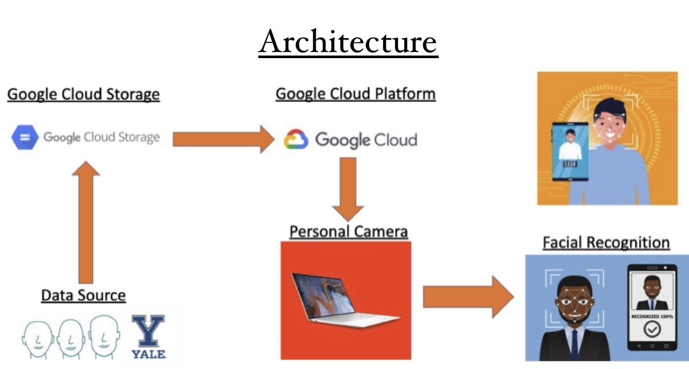

ETL

Datasets

The first data set that we have attempted to work with is from Yale University [1]. It is composed of 131 Facial Images of 13 subjects, and each with 10 different facial shots. The images as are all in grayscale. The reason for that is due to the image memory size. The larger the image and the more colors each image has the longer it takes for the algorithm to process and train. Therefore, in turn it requires more computing power. Instead, we opted to use the grayscale images. The plan is to use this sample to learn how the facial detection really works. As for our second dataset, we are going to be drawing it from our local machines. Meaning, we will be taking the face images using either our laptop cameras or from our phones. However, these images will not be used for facial detection. Instead, we are going to be using these images for our facial recognition application part.

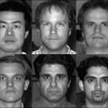 [1] Yale University Dataset Image Cover Sample

Data Selection

When it comes to our first dataset that from Yale University, we won’t have to do much. What we mean is, we won’t have to try to clean any data. Almost everything is already done for us. Any bad images have been already taken out and they are already gray scaled. The reason for our choice of this data, is primary due to the fact we would be using Yales coding samples for our facial detection algorithm. The fact that the data is clean was a bonus for us. However, we are not going to be so lucky for our second dataset. Our second dataset as mentioned before would be coming from us. Therefore, our only image source would be coming from us two or any induvial whom we want to train the algorithm to recognize. Our first part would be to take the facial images. The second part would be for us to programmatically alter the images. The program that would be written in “ipynb” file would be to alter the image size and change the coloring of the image. The reason for our color change as mentioned before is due to the file size. As such we want to minimize as much as possible the pixels count and color without having to hinder the facial detection and recognition algorithms.

Example of Image and Code Alteration Process Flow:

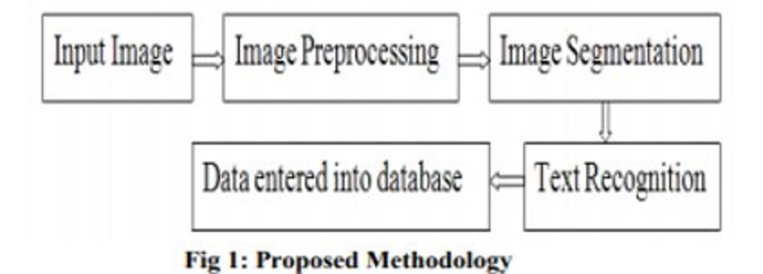

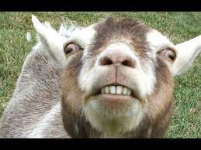

Step 1: Find and image and change it to smaller size

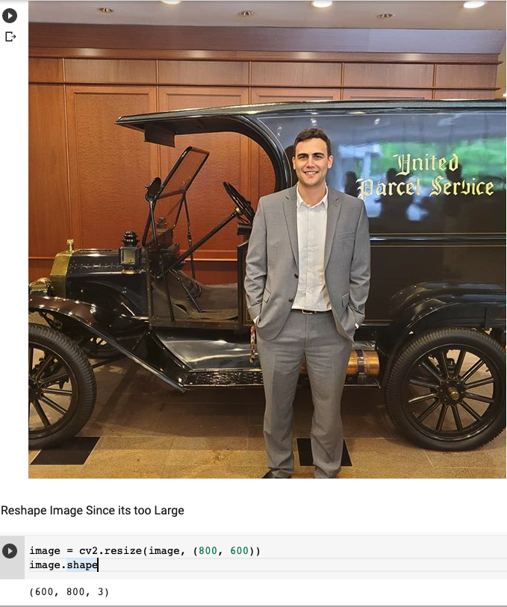

Step 2: Make It grayscale to only have 2 colors white and black. Goal is to minimize the RGB (Red – Green – Blue) color

Please Note the image below is more stretched and altered pixels count and size comparing to the original image in Step 1.

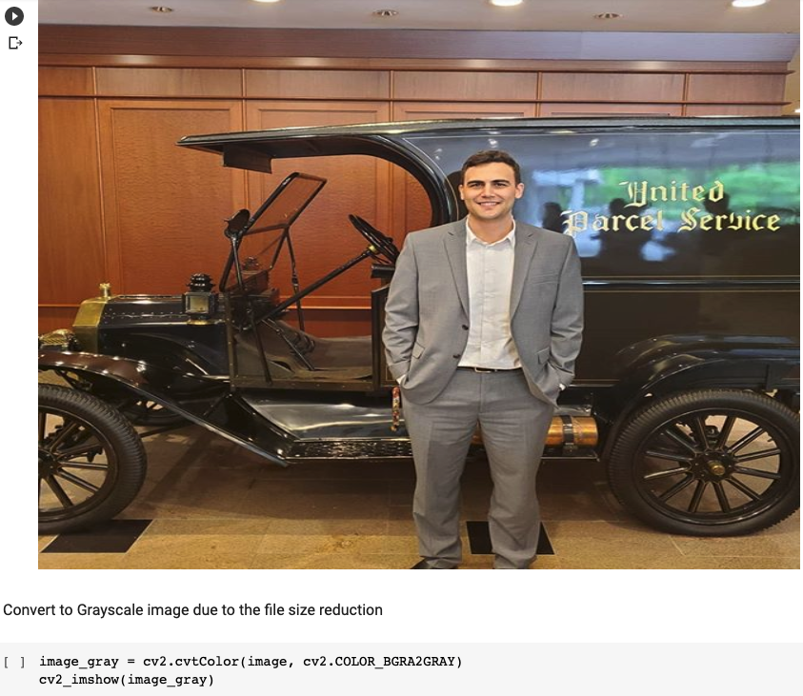

Step 3: This is the final product of an image example transformation process. The last part of all of this is to repeat it for each and every image in a given dataset.

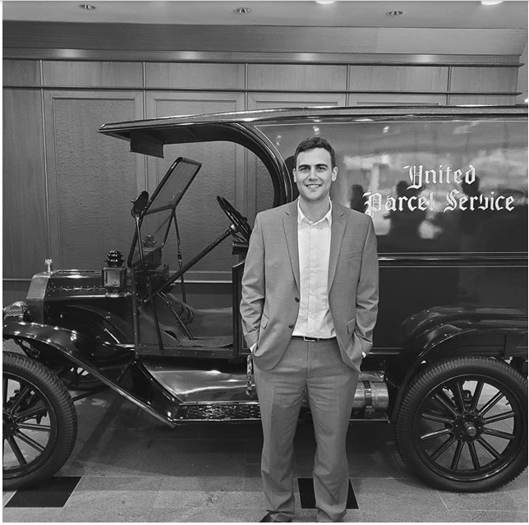

Data Stitching

The closest data stitching for us would be to capture the faces of all individuals. What do we mean by that is, the individuals that are going to be the home owners. Of course, when we want to train the algorithm to recognize the selected few individuals, they would have to upload their images. We believe the process of having to re-upload the images of not only same individual but other individual and re-train the algorithm would be considered a part of data stitching. Reason for that is, this is the part that we are using the data to be more meaningful to our algorithm.

Facial Detection

Facial Detection

The language of choice we have selected for our project would be Python. The reason for choosing the Python was primary due to the quantity of content available online on Computer Vison. We will be using libraries from OpenCV and specify CV2 and cv2_imshow. This type of technological use can be summarized as object detection technology. It is used to detect objects on both images and videos. On very high level it is due to it detecting on a single image or in video frame by frame. For our local machine we will only need to install 2 libraries via PyCharm terminal. And they are: “pip install opencv-python” and “pip install opencv-contrib-python”[2].

We have mentioned before we had to minimize the size of our images. Let us try to go in depth little more to better understand the reason behind it all. Each image has a size for example 1200 X 800. What does that mean Is that the height of the image is 1200 pixels and width 800. When multiplied we have in total 960,000 pixels. That is a very large number of pixels. However, each pixel has 3 colors to it Red, Green, and Blue. Therefore, not the image no longer has 960,000 pixels, instead its now 3 times 960,000. Meaning, our image actually has 2,880,000 pixels. Now that is a large number of pixels. To reduce the size we will only make it gray scale.

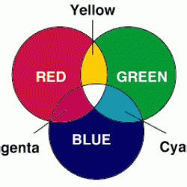[3] RGB colors

Now that we understand the reason behind the image color and size change, we will try to walk through the facial detection process. Our first part is to select an image. And after we select an image, we will introduce something called “Haar feature-based cascade classifiers”. In shot this is a pre-defined pointers on an image. In short, if an image has these depths and shapes then this image has this object. For example, we are trying to find if an image has a face on it. For it to do that, it has to see if that face has eyes, mouth, nose, etc. When those are met, then it will say it has detected the face. Haar feature-based cascade classifiers is XML file with paramattas that need to be met for it to detect a face or any object it is classified to detect.

Our classifier of choice was Frontal face since we want to detect faces [4]. For it we would need to import it and then add the outputs of the points over the original image to show the facial detection points.

Example:

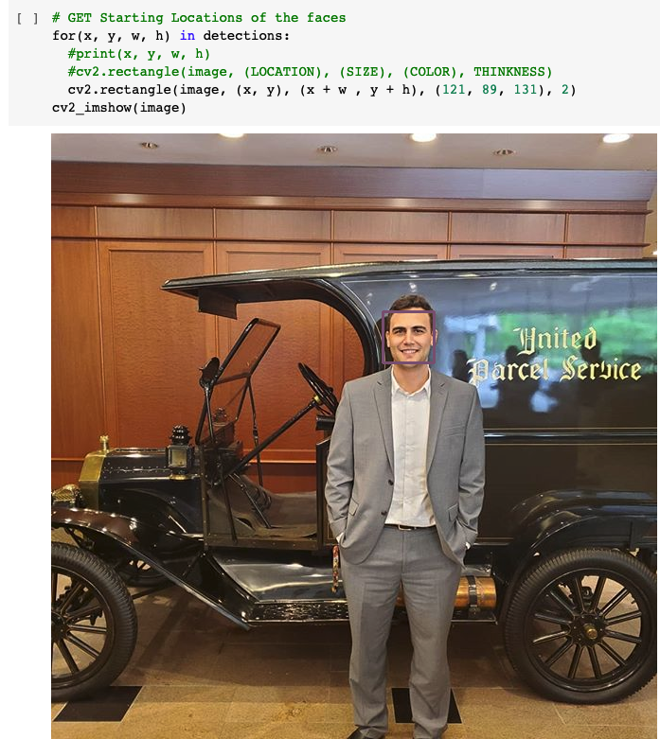

Facial Recognition

We would be using another example of classifier however this one is called “lbph_classifier”[5]. LBPH stands for Local Binary Pattern Histogram, and it is another part of OpenCV library. At this point we believe we wound need to try to train this classifier to recognize the face. The way this classifier work is little bit different. It checks the surrounding pixels and matches the image depth and then assigns 1s and 0s. Meaning the image would end up carrying even less data when its being processes by the algorithm. We would try to implement this algorithm to do it in live time using our own camera. And lastly, we will use Convolutional Neural network (CNN) [7] for the facial recognition.

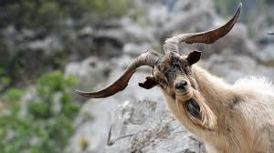

How about that Code example? Classifier VS Dlib CNN

Classifier LBPH

Step 1: After importing libraries needed. We would need to get images we would like to use to train our model. We need to convert the images in NumPy format array.

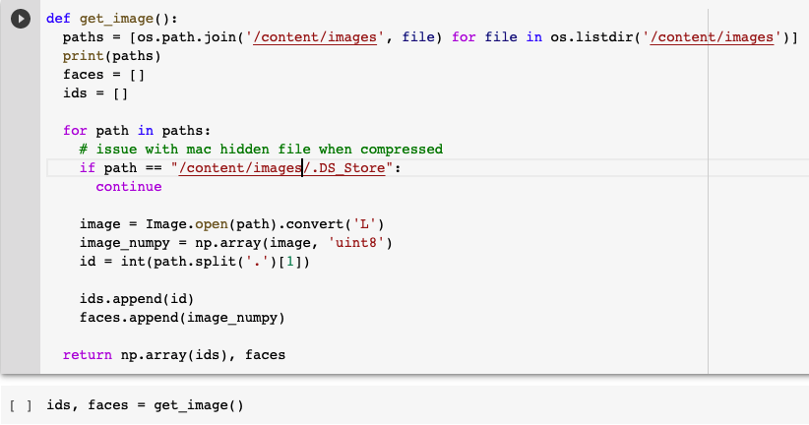

Step 2: We need to create an “yml” file that will contain all the information for our classifier to detect trained faces.

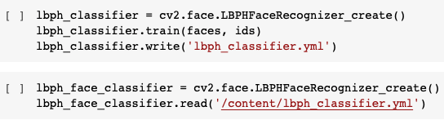

Step 3: Run the Facial Recognition function.

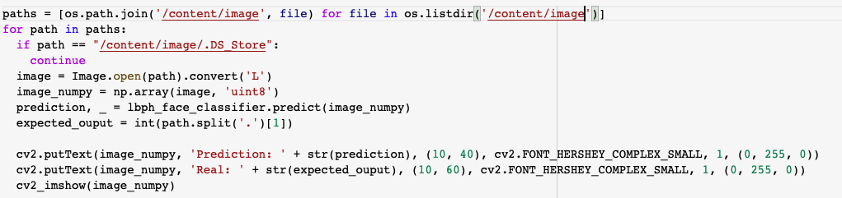

Dlib CNN (Convolutional Neural Network)

Step 1: After importing libraries needed. We would need to get images we would like to use to train our model. We need to convert the images in gray scale and set them up as numpy array. Now we want to detect the faces using the “dlib.get_frontal_face_detector()” and this is just a method in dlib library. We will also use something weights and that is a “dat” file that contains information about how the CNN is going to be learning faces that are given to it. In addition, we can set the amount of pointer we want on the face landmarks file. The more marks are added the more accurate the CNN will be however it takes longer to process. Therefore, if less are required the faster the processing is and the worst the accuracy gets.

­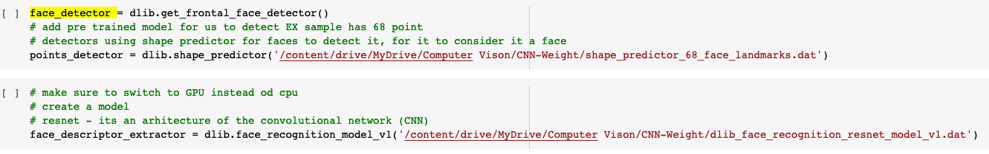

Step 2: Add the Points found in the points detector for it to be later ingested to face descriptor. That is also depending on how many faces are there to use to be trained.

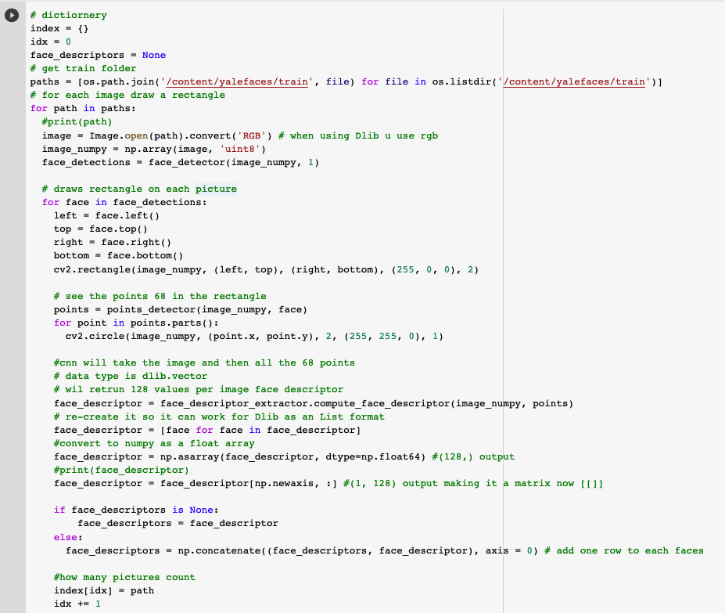

Step 3: Small example of the pointers of the face detected on the image.

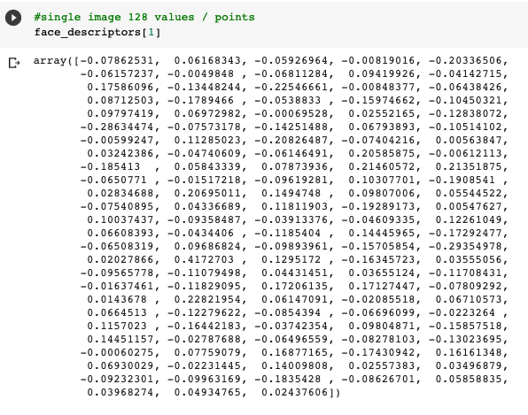

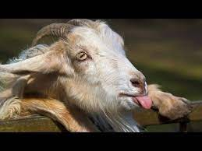

Step 4: All above done in a single image*. However, done each image at a time. Lastly, allow the algorithm predict vs test sample give.

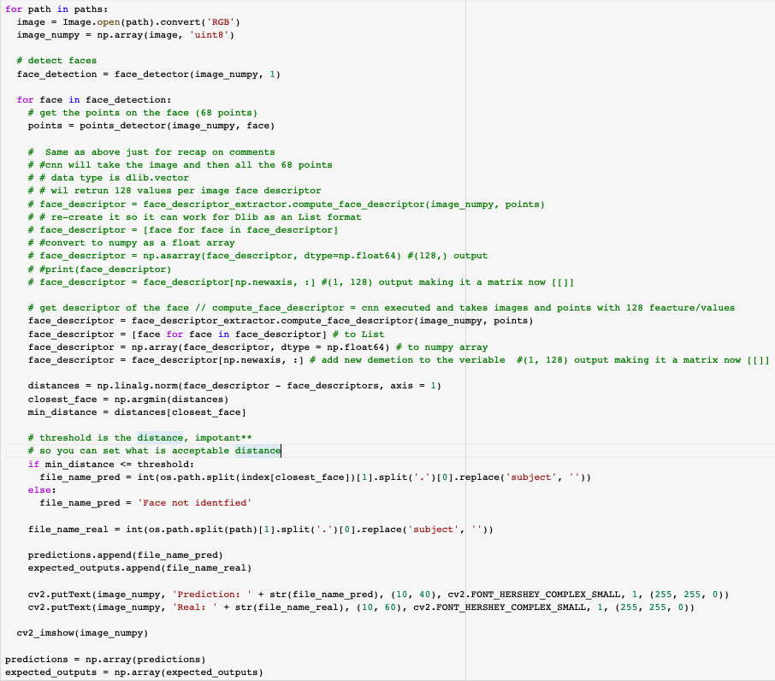

Step 5: Result Sample of the output. Of course, there would be some images not found. However, there were only 2.

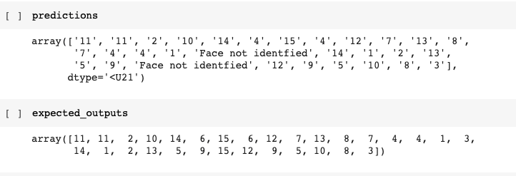

Extra gesture

An additional feature that the team had in mind was to use is a “911” feature that allows for the ring user to alert the authorities if an unidentified person is attempting to enter the home. We would utilize Convolutional Neural Network again. This would help the owner to further be alerted to what is going on while they are away from the home and confirm that there is an intruder so they could handle the situation accordingly.

Step 1: First step is to be able to get the points of the body correct. By default, there are 15 points on the body pre-defined by the algorithm. To start that we need to select an image to show the process of the CNN training.

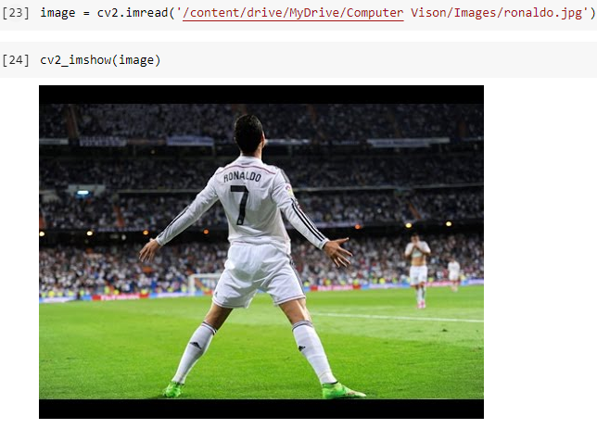

Step 2: Reconfigure the image shape and format to fit the modeling format. It needs to fit the blob format. It utilizes Mean Subtraction to distinguish between other body parts. 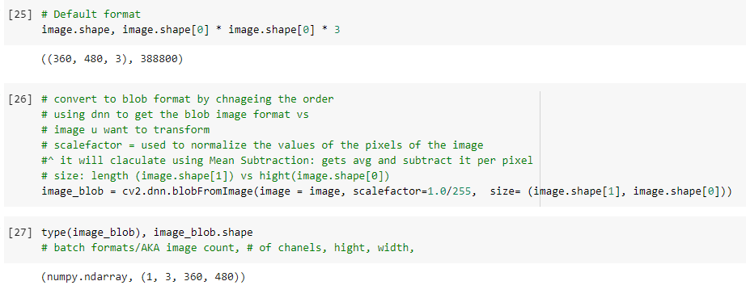

Step 3: Load the weights to train the model to identify the body parts. 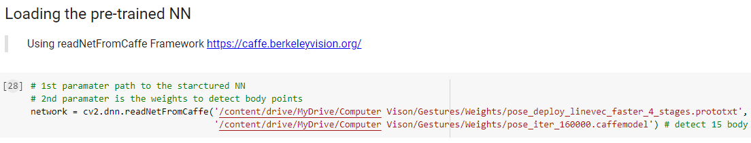

Step 4: Show/Identify the 15 body points on the image found.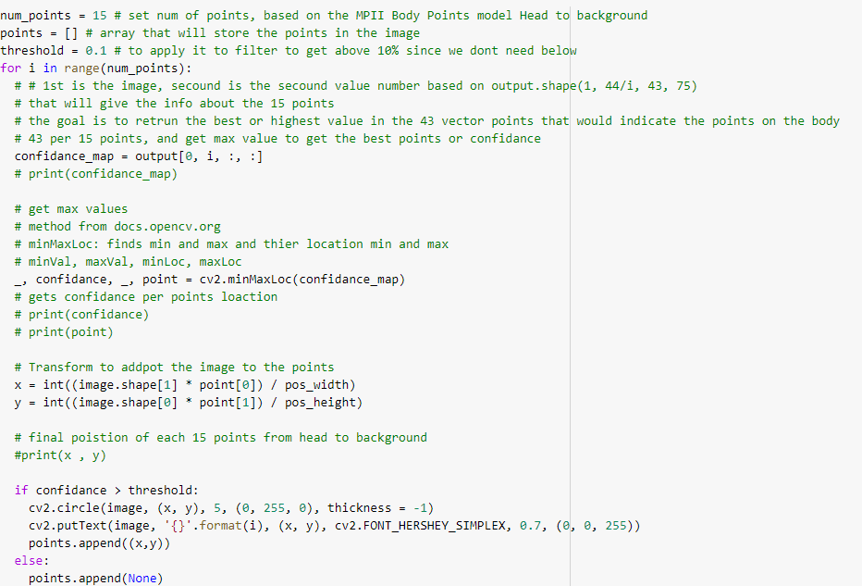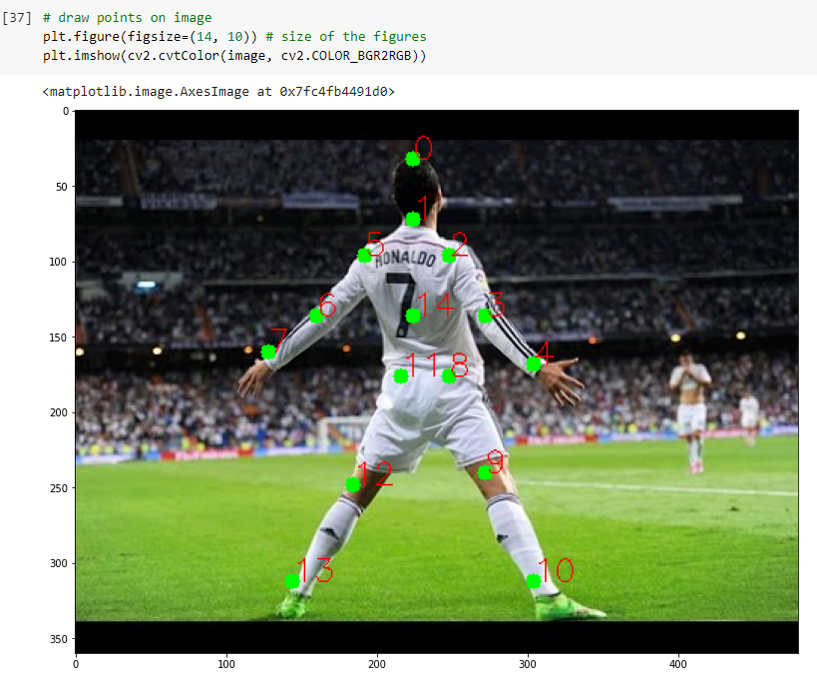

Step 5: Connect the points using “bones”.

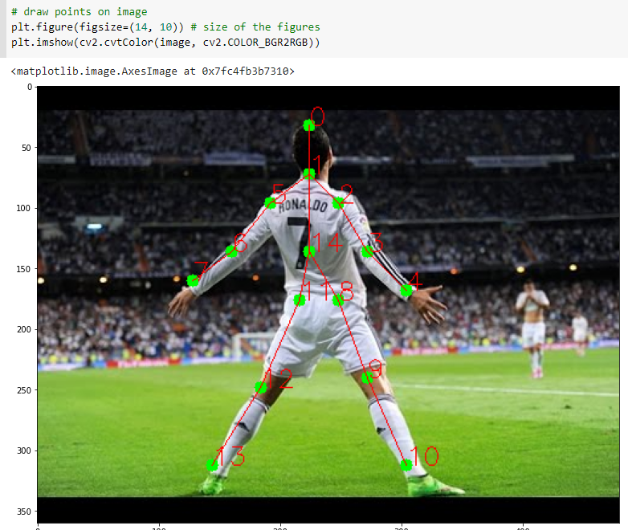

Step 6: From here the idea was to calculate the points X, Y against other points to distinguish if the body had a certain position that also included the object “gun”.

Google Cloud Storage

To continuously store the images and provide a place from which to directly pull images from we utilized the google cloud storage platform. We created a bucket, upload the photo files to that bucket, downloaded the files form the bucket by blob name, then printed the bucket list [12]. The bucket acted as a cargo holding our images and allowing us to pull them for recognition when needed. We enabled the google cloud storage json API, created a credential service account that placed us as the owner, so we have full access. We also created a private service key for the json file to maintain private access. The photos were able to be pulled in by way of the google command library we pip installed. Having the photos uploaded to google cloud gives our images enough storage to capture as many people as needed while giving us control of privacy access and allowing for images to be loaded straight into our code.

Step 1: Download GCP Storage: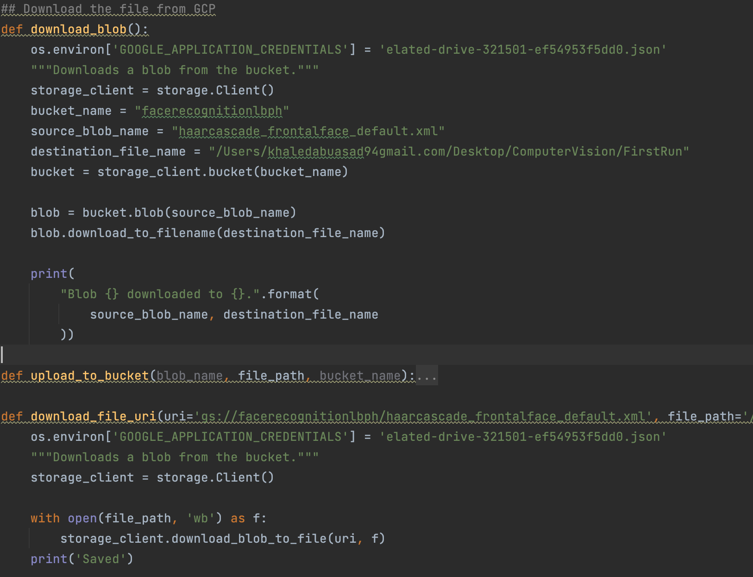

Step 2: Upload Documents to GCP Blob:

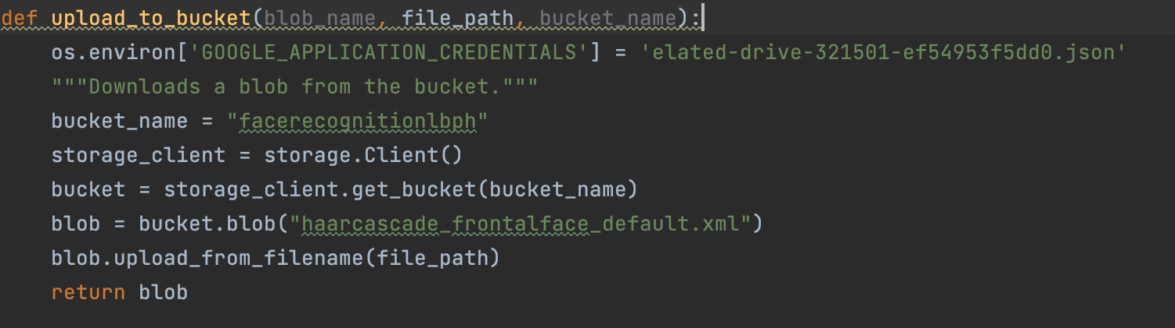

Conclusion

Our facial recognition project begins with the Yale dataset full of facial views to aid in training towards individual facial identification. Python and PyCharm would then be used on trained datasets along with GCP to automate the process and present YML to generate the identification. ETL would then be used on the Yale dataset to train for recognition rather than detection. When it comes to data selection, we were sure to consider image color and size was consistent with one another, this includes making the images smaller and grayscale. Pixels are analyzed and given binary indicators to determine the result and give an accurate output. In addition, we have started to work on the gesture. It will work by identifying 15 points on the body and distinguish each point using CNN. However, we didn’t have enough time to achieve the last piece of the puzzle. We used Google cloud storage to safely store our images and pull them into the recognition code using python. In conclusion we have managed to detect face, recognize face, and identify body parts using CNN, Classifiers, and models.

Yay! You made it through!

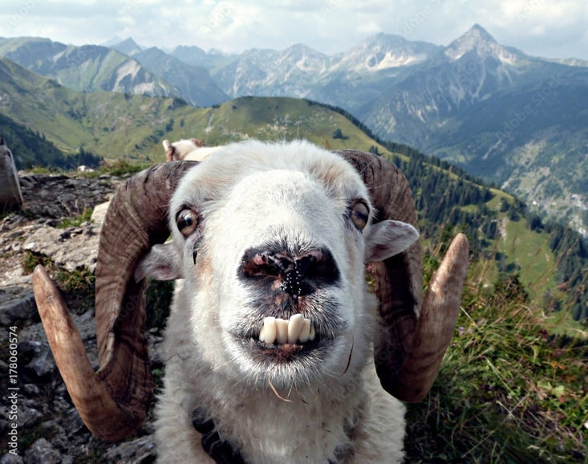[6]

REFERANCES:

[1] <http://vision.ucsd.edu/datasetsAll>

[2] <https://www.datacamp.com/community/tutorials/face-detection-python-opencv>

[3] <https://www.howtosmile.org/resource/smile-000-000-002-723>

[4]<https://github.com/opencv/opencv/blob/master/data/haarcascades/haarcascade_frontalface_default.xml>

[5] <https://towardsdatascience.com/face-recognition-how-lbph-works-90ec258c3d6b>

[6] <https://stock.adobe.com/search?k=crazy+goat&asset_id=17806057>

[7] <https://arxiv.org/abs/1512.03385>

[8] <https://www.pyimagesearch.com/2017/11/06/deep-learning-opencvs-blobfromimage-works/>

[9] <http://human-pose.mpi-inf.mpg.de/#dataset>] – additional data source

[10] <https://colab.research.google.com/drive/1obMQWIgEGPu8V7srdPr7lzQskXozOk2_#scrollTo=wLacyE5J6AwD>

[11] https://colab.research.google.com/drive/1tDBzKela-T_b6dAxO7pwlpoyeeICySca?usp=sharing

[12] <https://learndataanalysis.org/source-code-using-google-cloud-storage-api-in-python-for-beginners/>

Additional:

https://learnopencv.com/histogram-of-oriented-gradients/